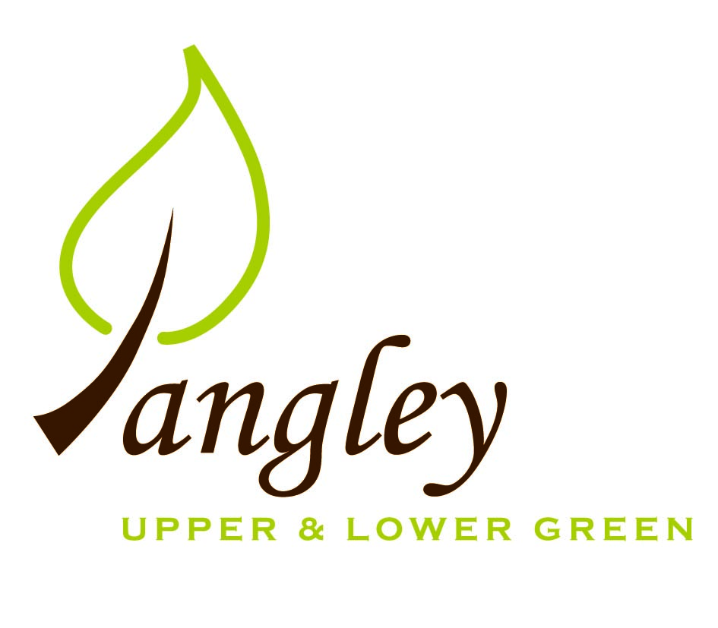

Clerk: Erica Williams
E-mail: langleyclerk@googlemail.com
13 Princes Close, Balsham, Cambridgeshire CB21 4EE

A MEETING OF LANGLEY PARISH COUNCIL
HELD AT LANGLEY COMMUNITY CENTRE ON
MONDAY 12^{h} May 2025 at 8.00pm

MINUTES
Attended: Cllr Elkington (Chair), Cllr North (Vice-Chair), Cllr Smith, Cllr Oliver
Minutes: Erica Williams (Clerk)

1. APOLOGIES FOR ABSENCE
Cllr Barnes, Cllr Clark

2. DECLARATION OF INTERESTS
It was proposed and agreed by all that Langley Parish Council is the registered owner of the village green and Councillors declare general
interests in all agenda items relating to the village green. Any other interests would be declared in the usual way.
- Cllr Elkington: 7.1 non-pecuniary, member of the Parish Council that owns the land on which the community centre is built.
- Cllr North: 7.1 non-pecuniary, member of the Parish Council that owns the land on which the community centre is built.
- Cllr Smith: 7.1 non-pecuniary, member of the Parish Council that owns the land on which the community centre is built.

3. PUBLIC PARTICIPATION SESSION WITH RESPECT TO ITEMS ON THE AGENDA AND OTHER MATTERS THAT ARE OF MUTUAL INTEREST
3.1 Three members of the public attended.

4. MINUTES OF THE LAST MEETING
4.1 Councillors were asked to review the Minutes of the Parish Council meeting held on Monday 14th April. All agreed and Chair signed them off.

5. FINANCIAL CLARIFICATION
5.1 Financial Report – Bank reconciliation as at 30th April, the current account balance was £22,150.18 (First precept payment received). PC unpresented payments, £945.12 resulting in a current account balance of £21,205.06. Broken down as follows: Playground H&S funds £239.37, Ditches funds £1,670.00, Speed sign funds £4,014.14; PC funds £15,281.55. PC deposit account £10,657.43.
5.2 All Cllrs reviewed and agreed BACS run. Cllrs approved request from Clerk to pay invoices from Compact Contracting Services upon receipt as the grass cutting contract and payment amounts have already been approved.
5.3 The PC are drafting a Complaints Policy, which although not compulsory, is advisable. To be reviewed at next meeting.
5.4 Due to an administrative error, Cllrs George and Anderson failed to sign their Declaration of Acceptance of Office forms when co-opted. Advice has been sought from UDC and notice of vacancies forms will be posted on 13th May for a period of 14 days.
5.5 Clerk awaiting quote for noticeboard maintenance.
5.6 Grant from Hundred Parishes Society to be further discussed at next meeting, following meetings with pond specialists.
5.7 Clerk awaiting two further quotes for Parish Council insurance.
Items 5.8 – 5.16 Year End Accounts – Cllr North thanked Clerk for work to produce Year End accounts.
5.8 Year-end accounts (ending 31st March 2025), including Bank Reconciliation, Receipts and Payments and Analysis of Variances approved by Council and signed by Chair.
5.9 Internal Control Statement for Year Ending 31st March 2025 approved by Council and signed by Chair.
5.10 Financial & Management Risk Assessment reviewed – no further action required.
5.11 As neither the gross income nor gross expenditure exceeds £25,000 the PC are exempt from an external audit/limited assurance review;
5.12 Certificate of Exemption approved, dated and signed by RFO and Chair. Signed document to be submitted to PFK Littlejohns ASAP together with completed contact details form.
5.13 Internal Audit due to take place shortly.
5.14 Council reviewed and approved by resolution (Cllr Elkington resolved to approve, Cllr Smith seconded) the Annual Governance Statement 2024/2025 which was signed and dated by RFO and Chair.
5.15 Council reviewed and approved by resolution (Cllr Elkington resolved to approve, Cllr Smith seconded) the Accounting Statements 2024/2025 which were signed and dated by RFO and Chair.
5.16 Copies of the following documents to be published on website on Monday 2nd June.
a) completed certificate of exemption;
b) completed, signed and dated annual internal audit report;
c) completed, approved, dated and signed annual governance statement;
d) completed, approved, dated and signed summary accounting statements;
e) analysis of variances
f) bank reconciliation;
g) notice of the period for the exercise of public rights; Dates set as Tuesday 3rd June to Monday 14th July. Notice to be published on website and noticeboards on Monday 2nd June.

6. PLANNING APPLICATIONS/PROPERTY
6.1 UTT/25/1021/FUL Duddenhoe Grange, Upper Green – NO COMMENT

7. LANGLEY VILLAGE PROJECT
7.1 Church path to made more wheelchair friendly and options for this are being investigated. Bell Tower almost finished, then flooring and tiles to be done.

8. LOCAL ENVIRONMENT
8.1 Grass cutting schedule progressing.
8.2 Metal cage to be removed from tree on Village Green – Cllr Smith to action. UK Power Networks have trimmed trees in The Want. Further tree work required for a tree near to the playground and one near to Bury Farm. Clerk to seek quote from regular contractor.
8.3 Essex Highways have put a new pipe in at the corner of Waterwick Hill. Further updates to follow.
8.4 Cllr Elkington has contacted pond specialists about maintenance and improvement works. Further work required to source grant funding.
8.5 Permission still outstanding for VAS signs. Clerk and Cllr Gadd continue to chase Essex Highways.
8.6 Essex Highways and UDC in disagreement about the status of Long Ley. Discussions ongoing.
8.7 Cllr Elkington has drafted a submission for Essex Village of the Year award. Clerk to submit by the deadline of 2nd June.

9. PLAYGROUND
9.1 Clerk awaiting quote for maintenance works.

10. DISTRICT & COUNTY COUNCIL
Cllr Oliver provided an update to Cllrs and answered questions.

11. BACS PAYMENTS
11.1 Council agreed the following BACS payments to be made:
Langley Parish Council – BACS payments for May 2025
Compact Contracting Services | Grass cutting | BACS | £552.85
Erica Williams | Clerks salary | BACS | £392.27
 |  | Total | £945.12

12. MATTERS TO BE RAISED BY MEMBERS FOR THE NEXT AGENDA

13. DATE OF NEXT MEETING:
13.1 The next meeting will be on Monday 9th June 2025 at Langley Community Centre at 8.00pm.

