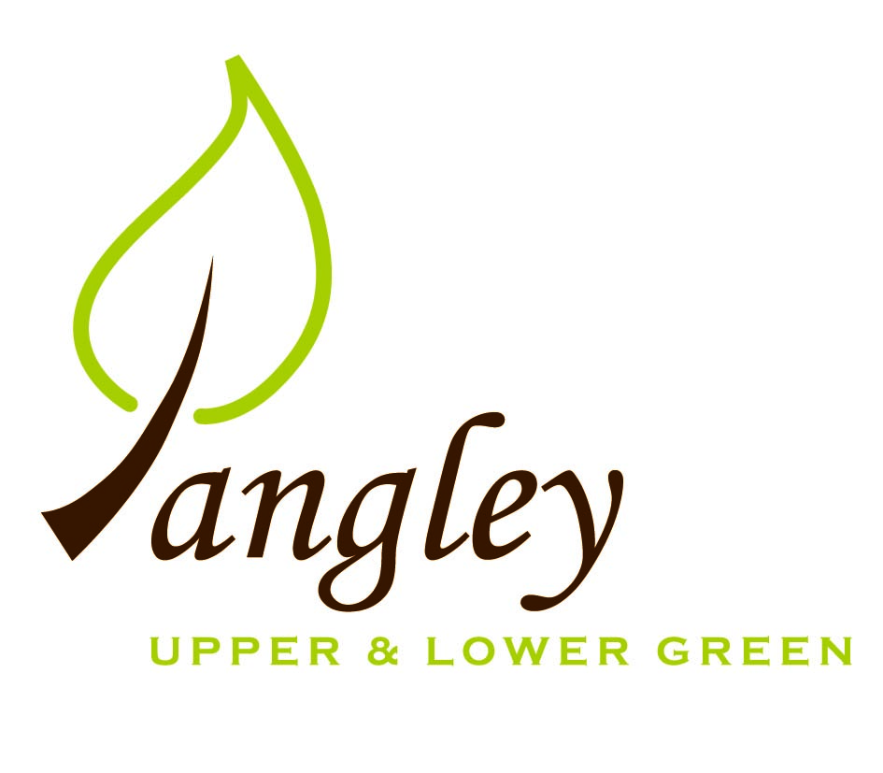

Clerk: Erica Williams
E-mail: langleyclerk@googlemail.com
13 Princes Close, Balsham, Cambridgeshire CB21 4EE

A MEETING OF LANGLEY PARISH COUNCIL
HELD AT LANGLEY COMMUNITY CENTRE ON
MONDAY 9th June 2025 at 8.00pm

MINUTES
Attended: Cllr Elkington (Chair), Cllr Clark, Cllr Barnes, Cllr Smith, Cllr Oliver arrived at 8.40pm
Minutes: Erica Williams (Clerk)

1. APOLOGIES FOR ABSENCE
Cllr North

2. DECLARATION OF INTERESTS
It was proposed and agreed by all that Langley Parish Council is the registered owner of the village green and Councillors declare general
interests in all agenda items relating to the village green. Any other interests would be declared in the usual way.
- Cllr Elkington: 7.1 non-pecuniary, member of the Parish Council that owns the land on which the community centre is built.
- Cllr Clark: 7.1 non-pecuniary, member of the Parish Council that owns the land on which the community centre is built.
- Cllr Barnes: 7.1 non-pecuniary, member of the Parish Council that owns the land on which the community centre is built. 6.2 personal, neighbouring property
- Cllr Smith: 7.1 non-pecuniary, member of the Parish Council that owns the land on which the community centre is built.
- Cllr George (following co-option): 7.1 non-pecuniary, member of the Parish Council that owns the land on which the community centre is built. 6.1 pecuniary, applicant.
- Cllr Anderson (following co-option): 7.1 non-pecuniary, member of the Parish Council that owns the land on which the community centre is built. 8.6 personal, resident of Long Ley.

3. PUBLIC PARTICIPATION SESSION WITH RESPECT TO ITEMS ON THE AGENDA AND OTHER MATTERS THAT ARE OF MUTUAL INTEREST
3.1 Three members of the public attended.

4. MINUTES OF THE LAST MEETING
4.1 Councillors were asked to review the Minutes of the Parish Council meeting held on Monday 12th May. All agreed and Chair signed them off.

5. FINANCIAL CLARIFICATION
5.1 Financial Report – Bank reconciliation as at 31st May, the current account balance was £21,199.06. PC unpresented payments, £1,240.92 resulting in a current account balance of £19,958.14. Broken down as follows: Playground H&S funds £239.37, Ditches funds £1,670.00, Speed sign funds £4,014.14; PC funds £14,034.63. PC deposit account £10,657.43.
5.2 All Cllrs reviewed and agreed BACS run.
5.3 The PC received two applications from parishioners for Cllr vacancies. Following presentations from both parishioners, both were co-opted onto the PC. The PC wish to welcome back Cllrs George and Anderson, who then signed their Register of Interest and Declaration of Acceptance of Office forms.
5.4 Cllrs reviewed Complaints policy. Cllr Elkington proposed that the PC adopts the complaints policy as presented. Cllr Clark seconded. All agreed.
5.5 Clerk has chased quote for noticeboard maintenance.
5.6 2 quotes were able to be obtained for PC insurance. Clerk suggested remaining with Clear Councils and figures to be circulated.
5.7 Clerk to circulate updates to Financial Regulations, Code of Conduct and Standing Orders for approval at next meeting.
5.8 Clerk has raised a complaint with UK Power Networks regarding the disconnection of electricity to the phone box in the Upper Green.

6. PLANNING APPLICATIONS/PROPERTY
6.1 UTT/25/0905/FUL Land west of Bull Lane, Langley Upper Green – The proposed dwelling is outside the village boundary in open countryside and the PC feel the visible aspect of the building will be intrusive.
6.2 UTT/25/1262/FUL Land west of Hill View, Langley Lower Green - No comment.

7. LANGLEY VILLAGE PROJECT
7.1 Church now has enough money to complete immediate projects. Langley Village Project has moved on but the two projects continue to work together to fundraise.

8. LOCAL ENVIRONMENT
8.1 Comments had been received about the amount of grass cuttings left on the Village Green but Cllr Smith reported an improvement in this. Playground grass is a little high – Clerk to speak to contractor.
8.2 Clerk to chase quote for tree works required and report overhanging trees in the Lower Green to Open Reach. Cllr Smith to remove cages on two trees on the Village Green.
8.3 Further updates to follow.
8.4 Essex Village of the Year competition has been entered.
8.5 Paperwork is now with Highways legal department for contracts to be drawn up for the VAS signs.
8.6 Long Ley status – no further updates.

9. PLAYGROUND
9.1 Contractor preparing quotes for maintenance.

10. DISTRICT & COUNTY COUNCIL
Cllr Oliver provided an update to Cllrs and answered questions.

11. BACS PAYMENTS
11.1 Council agreed the following BACS payments to be made:
Langley Parish Council – BACS payments for June 2025
Print Juice | Printing costs for Village Voice | BACS | £75.00
Compact Contracting Services | Grass cutting | BACS | £552.85
RCCE | Housing Needs Survey costs | BACS | £220.80
Erica Williams | Clerks salary | BACS | £392.27
 |  | Total | £1,240.92

12. MATTERS TO BE RAISED BY MEMBERS FOR THE NEXT AGENDA
RCCE / Low Cost Housing update
Asset Register
Risk Assessment forms

13. DATE OF NEXT MEETING:
13.1 The next meeting will be on Monday 14th July 2025 at Langley Community Centre at 8.00pm.

