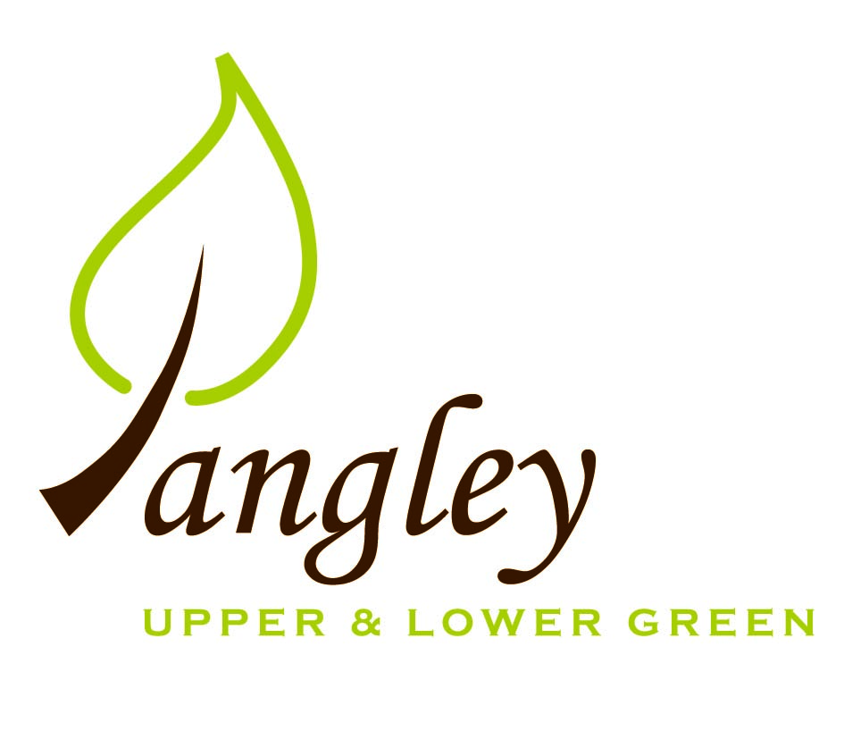

Clerk: Erica Williams
E-mail: langleyclerk@googlemail.com
13 Princes Close, Balsham, Cambridgeshire CB21 4EE

A MEETING OF LANGLEY PARISH COUNCIL
HELD AT LANGLEY COMMUNITY CENTRE ON
MONDAY 9th September 2024 at 8.00pm

MINUTES
Attended: Cllr Elkington (Chair), Cllr North, Cllr Anderson, Cllr Clark, Cllr George, Cllr Smith.
Minutes: Erica Williams (Clerk)

1. APOLOGIES FOR ABSENCE
Cllr Barnes.

2. DECLARATION OF INTERESTS
It was proposed and agreed by all that Langley Parish Council is the registered owner of the village green and Councillors declare general
interests in all agenda items relating to the village green. Any other interests would be declared in the usual way.
- Cllr Elkington: non-pecuniary, member of the Parish Council that owns the land on which the community centre is built.
- Cllr North: non-pecuniary, member of the Parish Council that owns the land on which the community centre is built.
- Cllr Smith: non-pecuniary, member of the Parish Council that owns the land on which the community centre is built.
- Cllr Anderson: non-pecuniary, member of the Parish Council that owns the land on which the community centre is built.
- Cllr Clark: non-pecuniary, member of the Parish Council that owns the land on which the community centre is built.
- Cllr George: non-pecuniary, member of the Parish Council that owns the land on which the community centre is built.

3. PUBLIC PARTICIPATION SESSION WITH RESPECT TO ITEMS ON THE AGENDA AND OTHER MATTERS THAT ARE OF MUTUAL INTEREST
3.1 One member of the public attended.

4. MINUTES OF THE LAST MEETING
4.1 Councillors were asked to review the Minutes of the Parish Council meeting held on Monday 8th July. All agreed and Chair signed them off.

5. FINANCIAL CLARIFICATION
5.1 Financial Report – Bank reconciliation as at 31st August, the current account balance was £16,565.07. PC unpresented payments, £498.63 resulting in a current account balance of £16,066.44. Broken down as follows: Playground H&S funds £239.37, Ditches funds £2,000.00, Speed sign funds £3,214.14; PC funds £10,612.93. PC deposit account £10,447.87. Clerk notified Cllrs that the interest rate from Unity Bank is decreasing from 2.75% to 2.60%.
5.2 All Cllrs reviewed and agreed BACS run.
5.3 Cllrs discussed a proposal to move to .gov.uk domain and email addresses for all to use for official PC business. Clerk to investigate process and costs and report back to the PC.
5.4 The Clerk’s laptop is very old and not running efficiently. Cllr Elkington proposed that a new one is purchased, out of the budget set aside for IT upgrades. Cllr George seconded. All agreed. Clerk to source and report back to the PC.

6. PLANNING APPLICATIONS/PROPERTY
6.1 UTT/24/2091/HHF – Nats Cottage, Upper Green – NO OBJECTIONS
6.2 UTT/24/2079/LB – Brooms, Langley Lower Green – NO OBJECTIONS

7. LANGLEY VILLAGE PROJECT
7.1 Request from LCC&ST to include minutes on PC website. Mezzanine now in place and Church is being redecorated (paid for by Friends of Langley Church).

8. LOCAL ENVIRONMENT
8.1 Grass cutting contract expires in March 2025. Tender needs to go out as soon as possible. Suggestion by Cllrs to specify the type of mower required for cutting the Village Green.
8.2 UK Power Networks will be carrying out site visit to look at the dead willow tree. Cllrs discussed 3 dead trees on the south side of the playground for which a quote has been received from Crown Tree & Garden Care for £300 plus VAT. Proposal from Cllr Elkington to accept this, seconded by Cllr North. All agreed. Further quotes required for trees on the Village Green. Cllr Smith to plant young Oak tree in October. Cllr Smith to start tree monitoring system using overhead photography and tagging of trees.
8.3 Cllr George had meeting with Highways last week and discussions have commenced regarding the clearing of drains and culverts to ease flooding on Bull Lane and Park Lane. Clerk to send letter to landowners with culverts that need clearing.
8.4 Application has started to obtain consent for VAS signs in three locations in the Upper Green. Cllrs to visit Lower Green and decide suitable locations. Clerk to present costings at next PC meeting.
8.6 The PC are pleased that track repair works in Upper Green are now complete.
8.8 The PC would welcome ideas or suggestions from residents around sports on the Green.
8.9 New bus service is now in operation but logistical problems with booking the service. Cllr North has written to the bus company highlighting concerns.
8.8 The withdrawal of landlines by BT has now been pushed back for a year.
8.10 Clerk still chasing disconnection of electricity to the phone box in Upper Green.
8.9 Clerk to request quote from RAS Handyman Services for noticeboard maintenance.
8.11 Cllrs discussed the findings of the Low Cost Housing Surveys and Clerk to book another meeting with RCCE to discuss next steps.

9. PLAYGROUND
9.1 Yearly inspection booked and will be carried out in November.
9.2 Cllr North has installed a new refuse bin at the playground. Residents are reminded that this is not to be used for dog waste.

10. DISTRICT & COUNTY COUNCIL
Cllrs Oliver and Gadd provided an update to Cllrs and answered questions.

11. BACS PAYMENTS
11.1 Council agreed the following BACS payments to be made:

Langley Parish Council – BACS payments for September 2024
Alan Hill | Installation of posts to the track at Upper Green (paid in August) | BACS | £100.00
Erica Williams | Clerks salary (paid in August) | BACS | £463.04
Cllr North | Reimbursement for purchase of wooden posts (paid in August) | BACS | £187.17
Erica Williams | Clerks salary | BACS | £374.63
Hundred Parishes Society | Membership renewal | BACS | £10.00
LGS Services | Internal Audit | BACS | £114.00
 |  | Total | £498.63
12. MATTERS TO BE RAISED BY MEMBERS FOR THE NEXT AGENDA
12.1 Updates to PC website

13. DATE OF NEXT MEETING:
13.1 The next meeting will be on Monday 14th October 2024 at Langley Community Centre.

