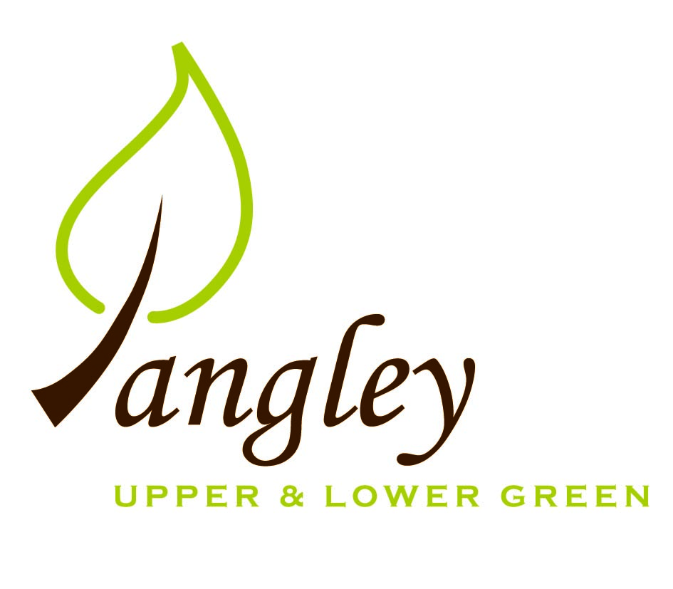

Clerk: Erica Williams
E-mail: langleyclerk@googlemail.com
13 Princes Close, Balsham, Cambridgeshire CB21 4EE

A MEETING OF LANGLEY PARISH COUNCIL
HELD AT LANGLEY COMMUNITY CENTRE ON
MONDAY 9th February 2026 at 8.00pm

MINUTES
Attended: Cllr Elkington (Chair), Cllr North (Vice-Chair), Cllr Smith, Cllr Clark, Cllr George, Cllr Anderson, Cllr Barnes
Minutes: Clerk

1. APOLOGIES FOR ABSENCE
None.

2. DECLARATION OF INTERESTS
It was proposed and agreed by all that Langley Parish Council is the registered owner of the village green and Councillors declare general
interests in all agenda items relating to the village green. Any other interests would be declared in the usual way.
- Cllr George 6.3: personal, applicant

3. PUBLIC PARTICIPATION SESSION WITH RESPECT TO ITEMS ON THE AGENDA AND OTHER MATTERS THAT ARE OF MUTUAL INTEREST
3.1 Two members of the public attended.

4. MINUTES OF THE LAST MEETING
4.1 Councillors were asked to review the Minutes of the Parish Council meeting held on Monday 12th January. All agreed and Chair signed them off.

5. FINANCIAL CLARIFICATION
5.1 Financial Report – Bank reconciliation as at 31st January, the current account balance was £12,029.41. PC unpresented payments, £564.03 resulting in a current account balance of £11,465.38. Broken down as follows: Playground H&S funds £0.00, Ditches funds £1,670.00, Speed sign funds £0.00; PC funds £9,795.38. PC deposit account £10,839.97.
5.2 All Cllrs reviewed and agreed BACS run.
5.3 Website construction has been delayed slightly, but should be ready to launch shortly.
5.4 Cllr North provided an update on Martyn’s Law legislation. Legislation has not come into effect yet so further information is outstanding.

6. PLANNING APPLICATIONS/PROPERTY
6.1 Asset of Community Value – The Bull PH – application now ready to submit to UDC. Clerk to action.
6.2 UTT/25/2442/FUL (Planning Appeal) – Land rear of Winterleigh, Upper Green – no additional comments.
6.3 UTT/25/0905/FUL (Planning Appeal) – Land west of Bull Lane, Upper Green - no additional comments.

7. LOCAL ENVIRONMENT
7.1 Grass cutting out of season currently – no updates
7.2 Clerk to approach two further tree surgeons for outstanding tree works. Cllr Smith to collect young Oak tree next week and clerk to speak to existing contractor about planting it on the Green.
7.3 A resident addressed the PC about potholes, particularly in the Lower Green with damage to verges and gulleys. Cllr George presented a synopsis of work that has been carried out to date. Phase 2 of ditch works includes grips and gullys. The resident further addressed a request for passing places. PC to speak to Highways about this. Discussions also took place around monitoring lorry movements through the village.
7.4 Clerk installing software for VAS signs next week and contractor ready to install signs.
7.5 Chair provided update to Cllrs following meeting with RCCE. Further updates to follow proceeding investigative works.
7.6 Following reports of parking on Common Land, the PC have written to residents and UDC, asking them not to park on Common Land.

8. PLAYGROUND
8.1 Annual inspection to take place shortly carried out by Wicksteed Leisure.

9. DISTRICT AND COUNTY COUNCIL
9.1 No District Councillor attendance.

10. BACS PAYMENTS
10.1 Council agreed the following BACS payments to be made:
Langley Parish Council – BACS payments for February 2026
Mr S McDowell | Reimbursement for service of scythe mower (paid in advance of meeting) |  | £127.52
Scribe Support Services | Monthly accounting fee |  | £31.20
Erica Williams | Clerks salary |  | £405.31
 |  | Total | £564.03

11. MATTERS TO BE RAISED BY MEMBERS FOR THE NEXT AGENDA

12. DATE OF NEXT MEETING:
12.1 The next meeting will be on Monday 9th March 2026 at Langley Community Centre at 8.00pm.

