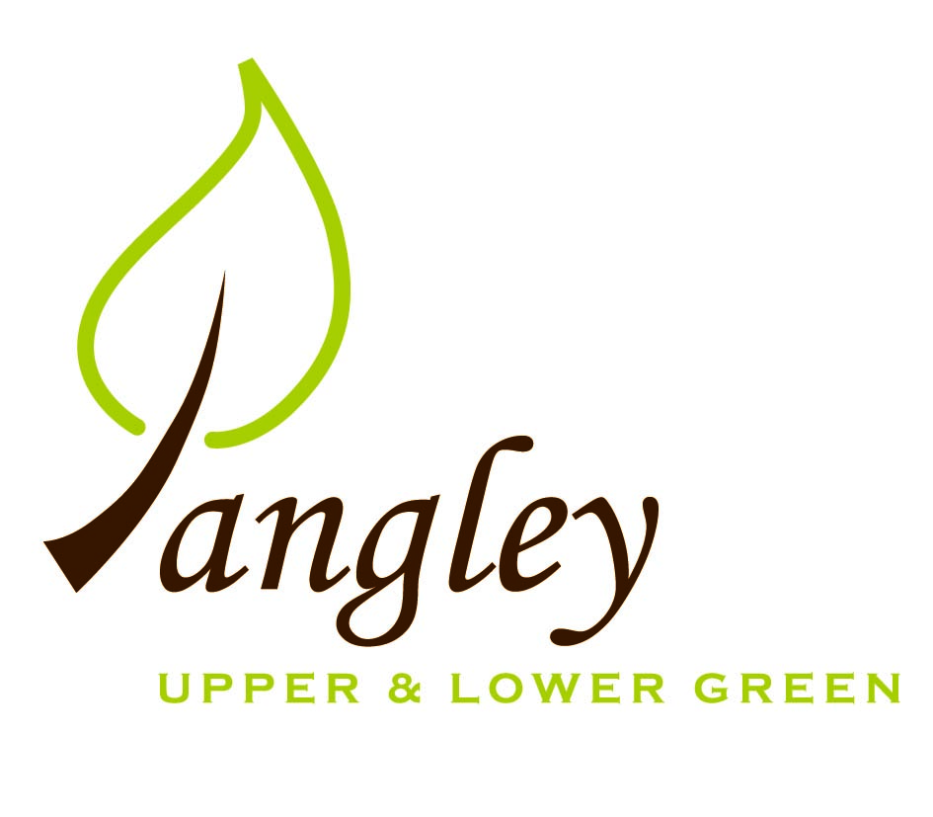

Clerk: Erica Williams
E-mail: langleyclerk@googlemail.com
13 Princes Close, Balsham, Cambridgeshire CB21 4EE

A MEETING OF LANGLEY PARISH COUNCIL
HELD AT LANGLEY COMMUNITY CENTRE ON
MONDAY 14th July 2025 at 8.00pm

MINUTES
Attended: Cllr Elkington (Chair), Cllr Clark, Cllr Barnes, Cllr Smith, Cllr George, Cllr Anderson
Minutes: Erica Williams (Clerk)

1. APOLOGIES FOR ABSENCE
Cllr North received ahead of meeting.

2. DECLARATION OF INTERESTS
It was proposed and agreed by all that Langley Parish Council is the registered owner of the village green and Councillors declare general
interests in all agenda items relating to the village green. Any other interests would be declared in the usual way.
- Cllr Elkington: 7.1 non-pecuniary, member of the Parish Council that owns the land on which the community centre is built.
- Cllr Clark: 7.1 non-pecuniary, member of the Parish Council that owns the land on which the community centre is built.
- Cllr Barnes: 7.1 non-pecuniary, member of the Parish Council that owns the land on which the community centre is built.
- Cllr Smith: 7.1 non-pecuniary, member of the Parish Council that owns the land on which the community centre is built.
- Cllr George: 7.1 non-pecuniary, member of the Parish Council that owns the land on which the community centre is built.
- Cllr Anderson: 7.1 non-pecuniary, member of the Parish Council that owns the land on which the community centre is built. 8.6 personal, resident of Long Ley.

3. PUBLIC PARTICIPATION SESSION WITH RESPECT TO ITEMS ON THE AGENDA AND OTHER MATTERS THAT ARE OF MUTUAL INTEREST
3.1 One member of the public attended.

4. MINUTES OF THE LAST MEETING
4.1 Councillors were asked to review the Minutes of the Parish Council meeting held on Monday 9th June. All agreed and Chair signed them off.

5. FINANCIAL CLARIFICATION
5.1 Financial Report – Bank reconciliation as at 30th June, the current account balance was £19,952.14. PC unpresented payments, £1,533.67 resulting in a current account balance of £18,418.47. Broken down as follows: Playground H&S funds £239.37, Ditches funds £1,670.00, Speed sign funds £4,014.14; PC funds £12,494.96. PC deposit account £10,719.77 (interest received of £62.34).
5.2 All Cllrs reviewed and agreed BACS run.
5.3 PC insurance renewed with Clear Councils.
5.4 After a review of the documents, Cllr Elkington proposed that the PC adopt updated Model Financial Regulations, Model Standing Orders and Code of Conduct. Cllr Clark seconded. All documents adopted by the PC.
5.5 Risk Assessment form to be formally reviewed at next PC meeting.
5.6 Clerk to make contact with PC solicitor for advice regarding ongoing dispute with UK Power Networks/SSE relating to electricity disconnection and finances for phone box in the Upper Green.

6. PLANNING APPLICATIONS/PROPERTY
6.1 None received.

7. LANGLEY VILLAGE PROJECT
7.1 As previously minuted, Langley Village Project has fulfilled its objective and no longer exists in it’s original format and as such, will no longer be minuted by the PC.

8. LOCAL ENVIRONMENT
8.1 The PC are pleased with the grass cutting schedule and quality. Long grass around the ditches will be cut before the Fete – clerk to confirm with contractor. Clerk to chase additional cuts around Potterills railings. Clerk to obtain quote from existing contractor for footpath clearance in Long Ley.
8.2 Quote received from existing contractor for £750 plus VAT to carry out tree works required. Cllrs approved quote. Cllr Smith to remove cage from tree on Village Green.
8.3 Essex Highways believe ditch work to be complete. PC contractor to carry out one days work – date to be confirmed. Clerk to send reminder to residents to log potholes so that list can be sent to Cllr Gadd.
8.4 FWAG have been contacted to review a pond in the Upper Green. The PC await further updates.
8.5 Permission still outstanding from Essex Highways for VAS signs. Clerk continues to chase.
8.6 Cllrs Elkington and North had further conversation with UDC to understand latest situation regarding status of Long Ley. The PC await further clarification from Uttlesford DC.
8.7 Dates offered by RCCE for meeting in August. Further updates to follow.

9. PLAYGROUND
9.1 Clerk to seek additional quotes for matting areas.

11. BACS PAYMENTS
11.1 Council agreed the following BACS payments to be made:
Langley Parish Council – BACS payments for July 2025
Clavering Parish Council | Green waste collection | BACS | £187.66
Erica Williams | Clerks salary | BACS | £485.09
Compact Contracting Services | Grass cutting (paid on 4/7/25) | BACS | £552.85
Clear Councils | Parish Council insurance | BACS | £710.92
LCC & ST | Community Centre hire | BACS | £150.00
 |  | Total | £2,086.52

12. MATTERS TO BE RAISED BY MEMBERS FOR THE NEXT AGENDA
12.1 PC website & email addresses for Councillors

13. DATE OF NEXT MEETING:
13.1 The next meeting will be on Monday 8th September 2025 at Langley Community Centre at 8.00pm (no meeting to be held in August).

