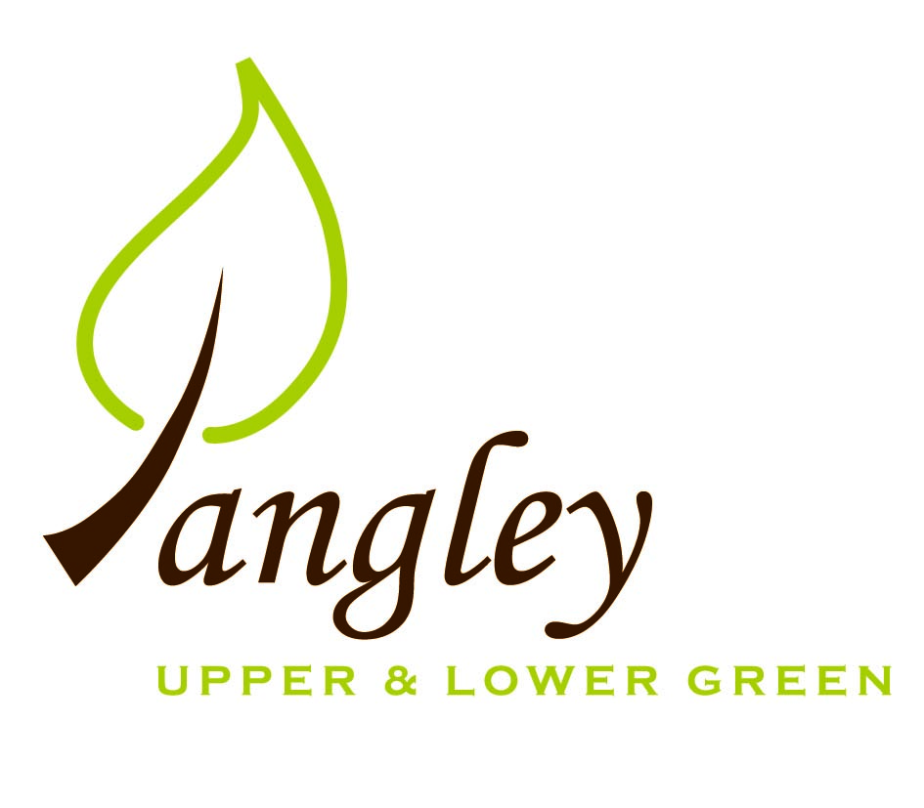

Clerk: Erica Williams
E-mail: langleyclerk@googlemail.com
13 Princes Close, Balsham, Cambridgeshire CB21 4EE

A MEETING OF LANGLEY PARISH COUNCIL
HELD AT LANGLEY COMMUNITY CENTRE ON
MONDAY 12th January 2026 at 8.00pm

MINUTES
Attended: Cllr Elkington (Chair), Cllr North (Vice-Chair), Cllr Smith, Cllr Clark, Cllr George, Cllr Anderson, Cllr Oliver arrived at 8.40pm
Minutes: Clerk

1. APOLOGIES FOR ABSENCE
Cllr Barnes.

2. DECLARATION OF INTERESTS
It was proposed and agreed by all that Langley Parish Council is the registered owner of the village green and Councillors declare general
interests in all agenda items relating to the village green. Any other interests would be declared in the usual way.

3. PUBLIC PARTICIPATION SESSION WITH RESPECT TO ITEMS ON THE AGENDA AND OTHER MATTERS THAT ARE OF MUTUAL INTEREST
3.1 One member of the public attended.

4. MINUTES OF THE LAST MEETING
4.1 Councillors were asked to review the Minutes of the Parish Council meeting held on Monday 10th November. All agreed and Chair signed them off.

5. FINANCIAL CLARIFICATION
5.1 Financial Report – Bank reconciliation as at 31st December, the current account balance was £12,631.75. PC unpresented payments, £596.34 resulting in a current account balance of £12,035.41. Broken down as follows: Playground H&S funds £0.00, Ditches funds £1,670.00, Speed sign funds £0.00; PC funds £10,365.41. PC deposit account £10,839.97 (interest received of £59.41).
5.2 All Cllrs reviewed and agreed BACS run.
5.3 Website construction on schedule and all documents have been sent to Aubergine.
5.4 Clerk ran through proposed precept 2026/7 figures. Cllr Elkington proposed that the figures presented are submitted to UDC. All agreed. Clerk to action.
5.5 Cllr George suggested that there be a PC representative at LCC&ST meetings. Cllrs North, Smith and George happy to rotate.
5.6 Email received from the Fete Committee asking the PC to investigate Martyn’s Law. Cllr North to speak to UDC to understand responsibilities.

6. PLANNING APPLICATIONS/PROPERTY
6.1 The Bull – Asset of Community Value. Letters of support received. Cllrs Elkington and George to proceed to next steps.
6.2 UTT/25/3304/FUL Barn east of The Gables, Langley Upper Green – NO COMMENT

7. LOCAL ENVIRONMENT
7.1 Grass cutting up to date. Clerk to contact contractor to clear path/ditch at The Kangels.
7.2 Full plotted map sent to contractors for tree works with an instruction to action asap. PC to purchase an oak tree for the Village Green in memory of Ken Rivett.
7.3 Email received from Affinity Water requesting permission to work on verges in the Lower Green that are common land in order to replace piping. All agreed.
7.4 Lower Green speed sign installation to be delayed until Affinity Water work is complete. Upper Green sign to be installed asap.
7.5 Second RCCE Low Cost Housing report has been received. Further updates to follow after next steps meeting with RCCE.
7.6 Planting of permanent christmas tree on the Village Green to be revisited in March.

8. PLAYGROUND
8.1 Clerk has booked annual inspection. Email from resident about parking space at the playground. UDC have confirmed that there are no restrictions on parking in Long Ley and this is to be used whilst possible other options are explored with UDC. Preliminary discussions have taken place with UDC but no progress has been made.

9. DISTRICT AND COUNTY COUNCIL
9.1 Cllr Oliver provided updated to Cllrs and answered questions.

10. BACS PAYMENTS
10.1 Council agreed the following BACS payments to be made:
Langley Parish Council – BACS payments for January 2026
Erica Williams | Clerks salary | BACS | £501.14
Scribe Support | Monthly accounting services | BACS | £31.20
RCCE | Second stage housing survey | BACS | £64.00
Erica Williams | Reimbursement for website costs (paid in December 2025) | BACS | £360.00
 |  | Total | £596.34

11. MATTERS TO BE RAISED BY MEMBERS FOR THE NEXT AGENDA

12. DATE OF NEXT MEETING:
12.1 The next meeting will be on Monday 9th February 2026 at Langley Community Centre at 8.00pm.

