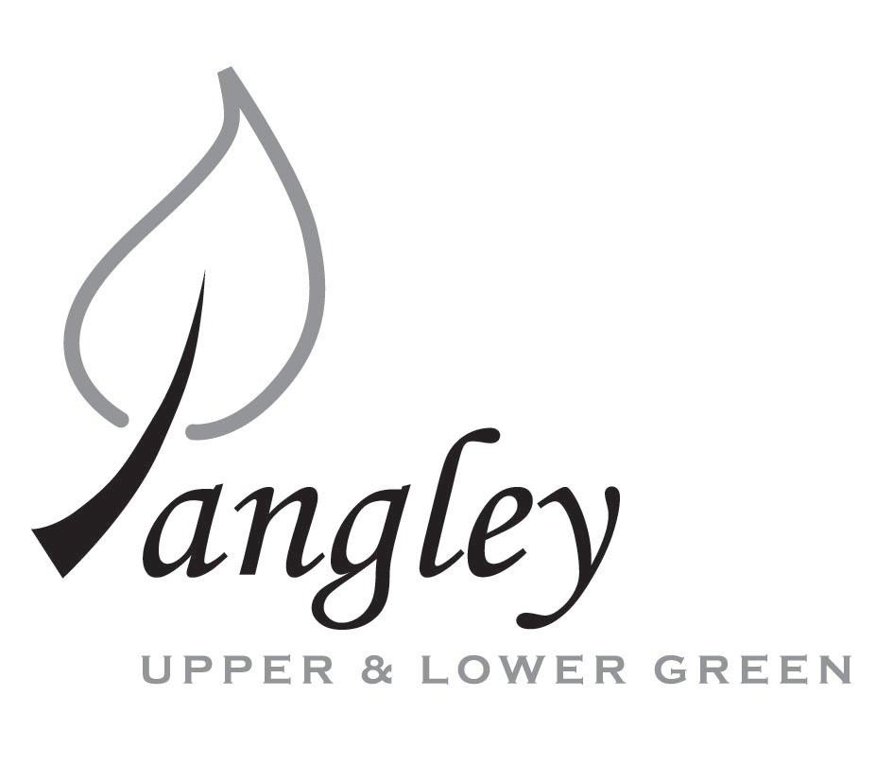
13 Princes Close, Balsham, Cambridgeshire CB21 4EE
E-mail: langleyclerk@googlemail.com
Telephone: 07539 249852

COUNCILLORS ARE SUMMONED TO ATTEND A MEETING OF LANGLEY PARISH COUNCIL
HELD AT LANGLEY COMMUNITY CENTRE ON
Monday 14th July 2025 at 8.00pm
THE PRESS AND THE PUBLIC ARE CORDIALLY INVITED TO ATTEND

This Parish Council supports the rights of anyone to record this meeting but advises that anyone so recording cannot disrupt the meeting, by means of the recording and expresses the hope that the person (or persons) carrying out the recording has obtained the necessary legal advice, for themselves, to ensure they understand the rights of any members of the public who may be present who do not wish to be filmed or recorded.

1. APOLOGIES FOR ABSENCE
1.1 To receive apologies for absence.

2. DECLARATION OF INTERESTS
2.1 To declare any disclosable pecuniary, other pecuniary or non-pecuniary interests relating to items on the agenda.

3. PUBLIC PARTICIPATION SESSION WITH RESPECT TO ITEMS ON THE AGENDA AND OTHER MATTERS THAT ARE OF MUTUAL INTEREST
3.1 The maximum time allowed for this item is 15 minutes. Members of the public who wish to comment on an Agenda item should do so at this point – maximum time allowed 5 minutes per Agenda item. Any questions raised shall not require a response at the meeting nor start a debate on the question. The Chair of the meeting may direct that a written or oral response be given.

4. MINUTES OF THE LAST MEETING
4.1 Councillors are asked to agree the Minutes of the Parish Council meeting held on Monday 9th June 2025, as a true and accurate account of the proceedings of the meetings.

5. FINANCIAL
5.1 Financial Report – Bank reconciliation as at 30th June, the current account balance was £19,952.14. PC unpresented payments, £1,533.67 resulting in a current account balance of £18,418.47. Broken down as follows: Playground H&S funds £239.37, Ditches funds £1,670.00, Speed sign funds £4,014.14; PC funds £12,494.96. PC deposit account £10,719.77 (interest received of £62.34).
5.2 Review of BACS payments.
5.3 Parish Council insurance
5.4 Review of Code of Conduct, Financial Regulations and Standing Orders
5.5 Risk Assessment forms
5.6 Electricity supply update

6. PLANNING APPLICATIONS/PROPERTY
6.1 None received.

7. LANGLEY VILLAGE PROJECT
7.1 Brief update from Village Project representatives.

8. LOCAL ENVIRONMENT
8.1 Grass cutting schedule and updates
8.2 Tree works update to include removal of cage around tree on Village Green
8.3 Update on revised ditch clearance programme and flooding
8.4 Ponds
8.5 Flashing speed signs update
8.6 Long Ley update
8.7 RCCE Low Cost Housing update

9. PLAYGROUND
9.1 Maintenance schedule update

10. DISTRICT AND COUNTY COUNCIL
10.1 Cllr. Oliver to provide District Council report.

11. BACS PAYMENTS
11.1 Council to agree to the following BACS payments to be made:
Langley Parish Council – BACS payments for July 2025
Clavering Parish Council | Green waste collection | BACS | £187.66
Erica Williams | Clerks salary | BACS | £485.09
Compact Contracting Services | Grass cutting (paid on 4/7/25) | BACS | £552.85
Clear Councils | Parish Council insurance | BACS | £710.92
LCC & ST | Community Centre hire | BACS | £150.00
 |  | Total | £2,086.52

12. MATTERS TO BE RAISED BY MEMBERS FOR THE NEXT AGENDA
12.1 Please note that no decisions can lawfully be made under this item. LGA 1972, Section 12 10(2)(b) states that business must be specified; therefore, the Council cannot lawfully raise matters for decision.

13. DATE OF NEXT MEETINGS
13.1 The next meeting will be on Monday 8th September 2025 at Langley Community Centre (no meeting to be held in August).

SIGNED (CLERK): | DATE:

