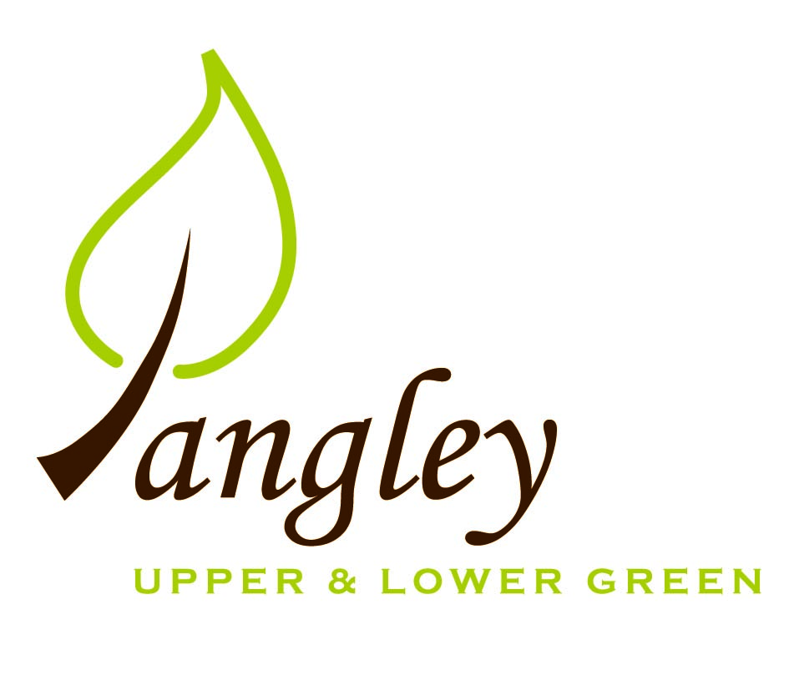

Clerk: Erica Williams
E-mail: langleyclerk@googlemail.com
13 Princes Close, Balsham, Cambridgeshire CB21 4EE

A MEETING OF LANGLEY PARISH COUNCIL
HELD AT LANGLEY COMMUNITY CENTRE ON
MONDAY 13th November 2023 at 8.00pm

MINUTES
Attended: Cllr Elkington (Chair), Cllr North (Vice-Chair), Cllr Smith, Cllr Anderson, Cllr Barnes, Cllr Clark, Melanie George (co-option). Cllr Oliver (UDC) arrived at 8.10pm
Minutes: Erica Williams (Clerk)

1. APOLOGIES FOR ABSENCE

2. PARISH COUNCIL VACANCY
2.1 The PC formally co-opted Melanie George and all paperwork was completed. All seven seats on the Parish Council are now filled.

3. DECLARATION OF INTERESTS
It was proposed and agreed by all that Langley Parish Council is the registered owner of the village green and Councillors declare general
interests in all agenda items relating to the village green. Any other interests would be declared in the usual way.
- Cllr Elkington: 8.1, non-pecuniary, member of the Parish Council that owns the land on which the community centre is built.
- Cllr North: 8.1, non-pecuniary, member of the Parish Council that owns the land on which the community centre is built.
- Cllr Smith: 8.1, non-pecuniary, member of the Parish Council that owns the land on which the community centre is built.
- Cllr Barnes: 8.1, non-pecuniary, member of the Parish Council that owns the land on which the community centre is built.
- Cllr Anderson: 8.1, non-pecuniary, member of the Parish Council that owns the land on which the community centre is built.
- Cllr Clark: 8.1, non-pecuniary, member of the Parish Council that owns the land on which the community centre is built.
- Cllr George: 8.1, non-pecuniary, member of the Parish Council that owns the land on which the community centre is built.

4. PUBLIC PARTICIPATION SESSION WITH RESPECT TO ITEMS ON THE AGENDA AND OTHER MATTERS THAT ARE OF MUTUAL INTEREST
4.1 Two members of the public attended. A parishioner spoke to Cllrs about concerns regarding the status of electricity supply to the village should more homeowners install electric charging points for vehicles.

5. MINUTES OF THE LAST MEETING
5.1 Councillors were asked to review the Minutes of the Parish Council meeting held on Monday 9th October. All agreed and Chair signed them off.

6. PRESENTATION FROM RCCE INTO LOW COST HOUSING STRATEGY
6.1 Laura Atkinson from RCCE gave a very information presentation to the PC on the provision of Affordable Rural Housing for Local People. The PC will discuss next steps at the next meeting.

7. FINANCIAL CLARIFICATION
7.1 Financial Report – Bank reconciliation as at 31st October, the current account balance was £23,546.38. PC unpresented payments, £728.05 resulting in a current account balance of £22,818.33. Broken down as follows: Playground H&S funds £1,317.37, Ditches funds £2,000.00, Playground funds £3,214.14; PC funds £16,286.82. PC deposit account £10,235.13.
7.2 All Cllrs reviewed and agreed BACS run.
7.3 Clerk, Cllr Elkington and Cllr North to meet to draft 2024/5 precept for approval at January meeting.
7.4 Clerk to send dates for New Councillor training in the New Year.

8. PLANNING APPLICATIONS/PROPERTY
7.1 None.

9. LANGLEY VILLAGE PROJECT
9.1 Drawings being re-done and sent to Diocese. Church fundraising ongoing. Carols on the Green for the Air Ambulance on 17th December and Carol Service on 10th December.

10. LOCAL ENVIRONMENT
10.1 Cllr Smith provided comprehensive list of trees work required in Long Ley. Clerk to seek quotes.
10.2 Landowner aware of metal waste that needs removing.
10.3 Footpath through Wickets is now clear.
10.4 Ditch clearance programme ongoing and commencement date to be agreed.
10.5 Cllrs Elkington and Smith have identified two locations on the Village Green for the new Oak trees. Cllr Smith to explore planting strategy when size of the trees is known.
10.6 The PC are aware of the potholes in Long Ley. UDC own the road and have previously made approaches for repair work. PC will again write to UDC and to all residents informing them on the current situation.
10.7 Following a parishioner request to fill in a pond, the PC received a report from Natural England confirming the presence of Newts in the pond. The pond therefore cannot be filled in. Some maintenance work is required though and Cllrs to make site visit.
10.8 Picnic benches on the Village Green. Clerk to send quotes to Cllrs.

11. PLAYGROUND
11.1 No updates.
11.2 Rubber waste has now been removed. Clerk has requested a quote for some replacement fencing and replacement matting that is required. Cllr North looking into the purchase of a new bin. Wicksteed carrying out playground inspection on 23rd November.

12. DISTRICT COUNCIL
Cllr Oliver gave an update and answered questions on this from Cllrs.

13. CHEQUES FOR SIGNING
13.1 Council agreed the following BACS payments to be made:

Langley Parish Council – BACS payments for November 2023
Open Spaces | Membership renewal | BACS | £45.00
EALC/NALC | Affiliation fees | BACS | £135.01
EALC | Rural Affordable Housing training (Cllrs Elkington & North) | BACS | £120.00
Erica Williams | Clerks salary | BACS | £428.04
 |  | Total | £728.05
14. MATTERS TO BE RAISED BY MEMBERS FOR THE NEXT AGENDA
14.1 Please note that no decisions can lawfully be made under this item. LGA 1972, Section 12 10(2)(b) states that business must be specified; therefore, the Council cannot lawfully raise matters for decision.
14.2 Low Cost Housing
14.3 Parking bay
14.4 Precept 2024/25

15. DATE OF NEXT MEETING:
15.1 The next meeting will be on Monday 8th January 2024 at Langley Community Centre (no meeting in December).

