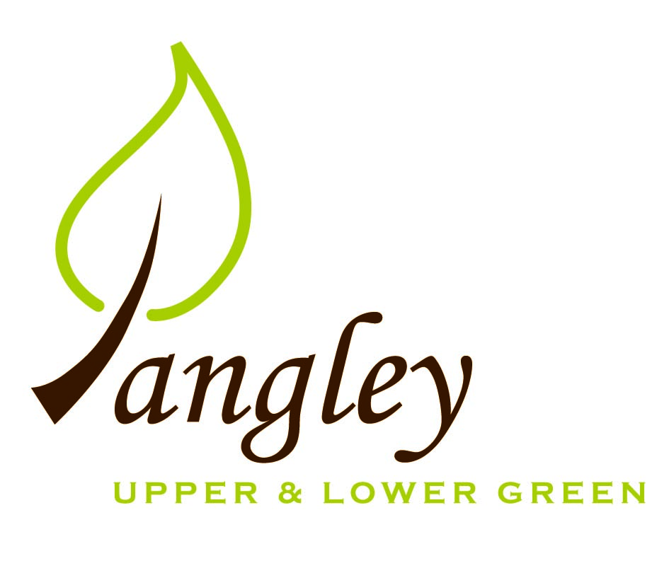

Clerk: Erica Williams
E-mail: langleyclerk@googlemail.com
13 Princes Close, Balsham, Cambridgeshire CB21 4EE

A MEETING OF LANGLEY PARISH COUNCIL
HELD AT LANGLEY COMMUNITY CENTRE ON
MONDAY 9th October 2023 at 8.00pm

MINUTES
Attended: Cllr Elkington (Chair), Cllr North (Vice-Chair), Cllr Smith, Cllr Anderson, Cllr Barnes, Cllr Clark. Cllr Oliver (UDC) arrived at 8.40pm
Minutes: Erica Williams (Clerk)

1. APOLOGIES FOR ABSENCE

2. DECLARATION OF INTERESTS
It was proposed and agreed by all that Langley Parish Council is the registered owner of the village green and Councillors declare general
interests in all agenda items relating to the village green. Any other interests would be declared in the usual way.
- Cllr Elkington: 8.1, non-pecuniary, member of the Parish Council that owns the land on which the community centre is built.
- Cllr North: 8.1, non-pecuniary, member of the Parish Council that owns the land on which the community centre is built.
- Cllr Smith: 8.1, non-pecuniary, member of the Parish Council that owns the land on which the community centre is built.
- Cllr Barnes: 8.1, non-pecuniary, member of the Parish Council that owns the land on which the community centre is built.
- Cllr Anderson: 8.1, non-pecuniary, member of the Parish Council that owns the land on which the community centre is built.
- Cllr Clark: 8.1, non-pecuniary, member of the Parish Council that owns the land on which the community centre is built. 7.1, personal connection with the family.

3. PUBLIC PARTICIPATION SESSION WITH RESPECT TO ITEMS ON THE AGENDA AND OTHER MATTERS THAT ARE OF MUTUAL INTEREST
3.1 Four members of the public attended. A parishioner spoke to Cllrs about a pond which he would like filling in for personal safety reasons. Cllr Elkington advised the parishioner that further discussions were necessary and the PC would revert back in due course.

4. MINUTES OF THE LAST MEETING
4.1 Councillors were asked to review the Minutes of the Parish Council meeting held on Monday 11th September. All agreed and Chair signed them off.

6. FINANCIAL CLARIFICATION
6.1 Financial Report – Bank reconciliation as at 30th September, the current account balance was £26,995.01 (second precept installment of £8,035.00 received). PC unpresented payments, £356.63 resulting in a current account balance of £26,638.38. Broken down as follows: Playground H&S funds £1,317.37, Ditches funds £2,000.00, Playground funds £3,214.14; PC funds £20,106.87. PC deposit account £10,235.13 (interest received of £69.05).
6.2 All Cllrs reviewed and agreed BACS run.

7. PLANNING APPLICATIONS/PROPERTY
7.1 Re-consultation UTT/23/0915/FUL Hall Farm, Langley Upper Green – NO OBJECTIONS
7.2 Cllr Elkington spoke to Cllrs about the Deed of Grant process and complications that arise from it. All agreed for Cllrs Elkington and North to engage with PC solicitor for clarification on access over Common lands.

8. LANGLEY VILLAGE PROJECT
8.1 Site visit with the Diocese Advisory Committee was cancelled. Proposal to install the framework so that it can be visualised.

10. LOCAL ENVIRONMENT
10.1 Trees / Verges / Grass cutting – Cllr Smith to formulate shortlist of trees that need uplifting in order to Clerk to seek quotes. Quote also to include stump grinding on the Village Green. Dead tree that had fallen to the rear of a property in Kangels has been cleared and footpath opened.
Quote received from GWB Horticulture for the removal of grass. Cllr Elkington proposed to accept the quote, Cllr Smith seconded, all agreed.
Cllr Clark to speak with landowner about two piles of metal waste/fencing/scrub in two locations at the read of The Cottage, Upper Green.
Cllr Smith to check the status of the footpath that runs through Wickets.
10.2 Cllrs Elkington and Smith to walk Village Green and pinpoint location for planting of young commemorative Oak Tree.
10.3 The PC would like to thank Dr Tony Yates for a fascinating and informative talk on the dangers of the Asian Hornet. Information will be communicated with parishioners in due course.
10.4 Discussions ongoing regarding the pond at The Causeway.
10.5 Discussions ongoing regarding traffic calming but Highways likely to not be in favour of traffic calming measures. PC to look into additional signage.
10.6 Clerk to circulate quotes for new picnic bench on the Village Green.
10.7 Cllr Elkington proposed that the PC fund a Christmas Tree to the value of £120 on the Village Green. Cllr Clark seconded. All agreed.
10.8 Clerk to send UDC Spending Review consultation to all Cllrs. Parishioners can submit their views at https://letstalk.uttlesford.gov.uk/uttlesford-district-council-budget-2024-25 until 5th November 2023.
10.9 Cllr Elkington reviewed the consultation sent by UDC on Polling Places. No comment needed from PC.
10.10 Date to be booked for Clerk and Cllrs to sort through PC documents ready for storage.

11. PLAYGROUND
11.1 No updates.
11.2 Red litter bin now removed from playground due to it being used inappropriately for dog waste. Clerk to book annual inspection with Wicksteed.

12. DISTRICT COUNCIL
Cllr Oliver gave an update and answered questions on this from Cllrs.

13. CHEQUES FOR SIGNING
13.1 Council agreed the following BACS payments to be made:

Langley Parish Council – BACS payments for October 2023
Erica Williams | Clerks salary | BACS | £346.63
Hundred Parishes Society | Membership renewal | BACS | £10.00
 |  | Total | £356.63
14. MATTERS TO BE RAISED BY MEMBERS FOR THE NEXT AGENDA
14.1 Please note that no decisions can lawfully be made under this item. LGA 1972, Section 12 10(2)(b) states that business must be specified; therefore, the Council cannot lawfully raise matters for decision.
14.2 Low Cost Housing
14.3 Potholes in Long Ley
14.4 Precept 2024/25
14.5 New Cllr training

15. DATE OF NEXT MEETING:
15.1 The next meeting will be on Monday 13th November at Langley Community Centre.

