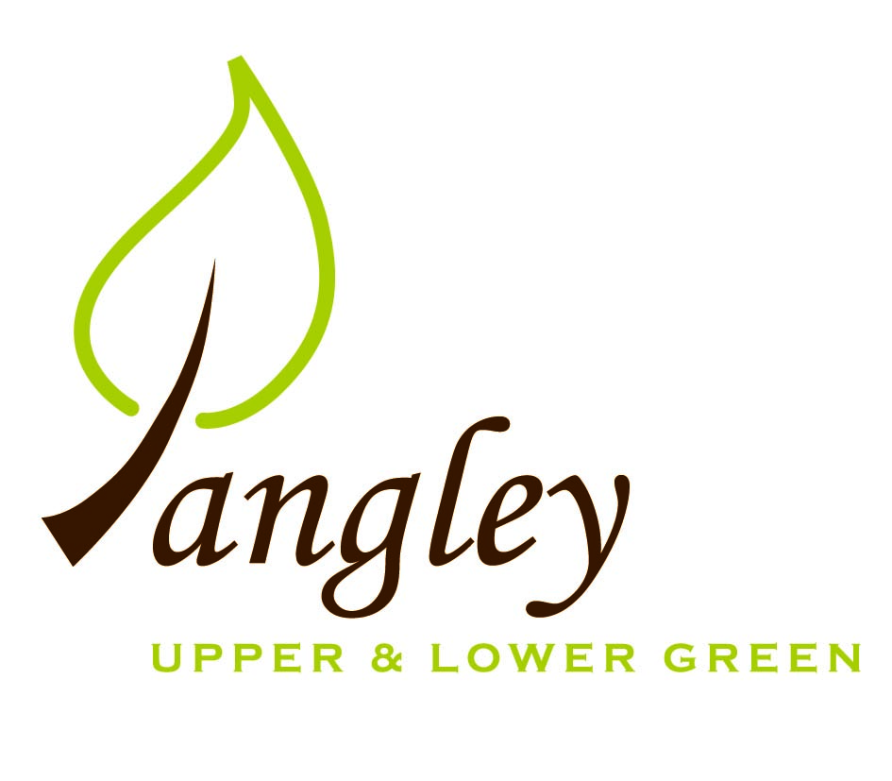

Clerk: Erica Williams
E-mail: langleyclerk@googlemail.com
13 Princes Close, Balsham, Cambridgeshire CB21 4EE

A MEETING OF LANGLEY PARISH COUNCIL
HELD AT LANGLEY COMMUNITY CENTRE ON
MONDAY 10th November 2025 at 8.00pm

MINUTES
Attended: Cllr Elkington (Chair), Cllr North (Vice-Chair), Cllr Smith, Cllr Clark, Cllr Barnes, Cllr George, Cllr Anderson, Cllr Oliver arrived at 8.40pm
Minutes: Clerk

1. APOLOGIES FOR ABSENCE
None.

2. DECLARATION OF INTERESTS
It was proposed and agreed by all that Langley Parish Council is the registered owner of the village green and Councillors declare general
interests in all agenda items relating to the village green. Any other interests would be declared in the usual way.
- Cllr Anderson 7.6 (personal) – resident of Long Ley

3. PUBLIC PARTICIPATION SESSION WITH RESPECT TO ITEMS ON THE AGENDA AND OTHER MATTERS THAT ARE OF MUTUAL INTEREST
3.1 Four members of the public attended. A resident informed the PC of changes to a planning application that will be submitted shortly. Councillors did not comment on the plans.

4. MINUTES OF THE LAST MEETING
4.1 Councillors were asked to review the Minutes of the Parish Council meeting held on Monday 13th October. All agreed and Chair signed them off.

5. FINANCIAL CLARIFICATION
5.1 Financial Report – Bank reconciliation as at 31st October, the current account balance was £22,176.38. PC unpresented payments, £989.36 resulting in a current account balance of £21,187.02. Broken down as follows: Playground H&S funds £239.37, Ditches funds £1,670.00, Speed sign funds £4,014.14; PC funds £15,263.51. PC deposit account £10,780.56.
5.2 All Cllrs reviewed and agreed BACS run. Additional payment added to run, which arrived too late for the agenda, but is an expected bill to pay. All Cllrs in agreement to add to BACS run.
5.3 Clerk provided update to Councillors on the new PC website, which is due to be completed mid-January. Cllr Elkington proposed that Langley PC adopt IT policy and Accessibility Statement. Cllr Clark seconded. All agreed.
5.4 Clerk is in the process of setting up Scribe accounting systems, further training to follow.
5.5 Quote received from existing contractor for making good of the surface around the basketball net. Agreement of quote was made prior to the meeting in order to avoid time delays and decision unanimously ratified at meeting.
5.6 Councillors reviewed the Risk Assessment document. Approved by all Councillors.
5.7 Date for submission of Precept 2026/7 is 23rd January 2026. Clerk, Cllrs Elkington and North to action and present to Councillors.

6. PLANNING APPLICATIONS/PROPERTY
6.1 Cllr George provided an update on the application for The Bull PH to be made an Asset of Community Value. All Cllrs agreed to put together a paragraph for inclusion in the Village Voice.

7. LOCAL ENVIRONMENT
7.1 Grass cutting schedule on track. Bulbs donated from a parishioner have been planted around the playground. A resident reported a blocked footpath at The Kangels/Long Ley. Clerk to speak to existing contractors for a quote to clear it.
7.2 Previous contractor to provide a quote for tree works required.
7.3 Pot holes have been filled last week. Further rainfall required to check effectiveness of ditch clearance programme. Additional pothole / water leak in the Lower Green to be reported.
7.4 Permission is now through from ECC for Vehicle Activated Speed Signs; 1 in the Lower Green and 1 location in the Upper Green. Two quotes received for purchase of units. Proposal by Cllr Elkington to purchase two VAS signs at a cost of £5,400. Cllr North seconded. All agreed. Clerk to action.
7.5 RCCE Low Cost Housing deadline for response to survey has now passed. Further updates to follow.
7.6 Clerk read an email from a parishioner (at their request) regarding the ongoing parking situation in Long Ley. Clerk to provide parishioner with a written response.

8. PLAYGROUND
8.1 Clerk has asked contractor to proceed with the work required to make good the area around the basketball net. Clerk to book annual inspection.

9. DISTRICT AND COUNTY COUNCIL
9.1 Cllr Oliver provided updated to Cllrs and answered questions. Clerk read an update from Cllr Gadd.

10. BACS PAYMENTS
10.1 Council agreed the following BACS payments to be made:
Langley Parish Council – BACS payments for November 2025
Ben Bull | Reimbursement for renewal of website domain (paid in October) | BACS | £15.99
Compact Contracting Services | Grass cutting | BACS | £552.85
Erica Williams | Clerks salary | BACS | £405.31
Scribe Support | Monthly fee | BACS | £31.20
Gary Law | Verges payment | BACS | £1350.00
 |  | Total | £2339.36

11. MATTERS TO BE RAISED BY MEMBERS FOR THE NEXT AGENDA
11.1 Planting of a tree on the Village Green in memory of Ken Rivett

12. DATE OF NEXT MEETING:
12.1 The next meeting will be on Monday 12th January 2026 at Langley Community Centre at 8.00pm (no meeting held in Decemer).

