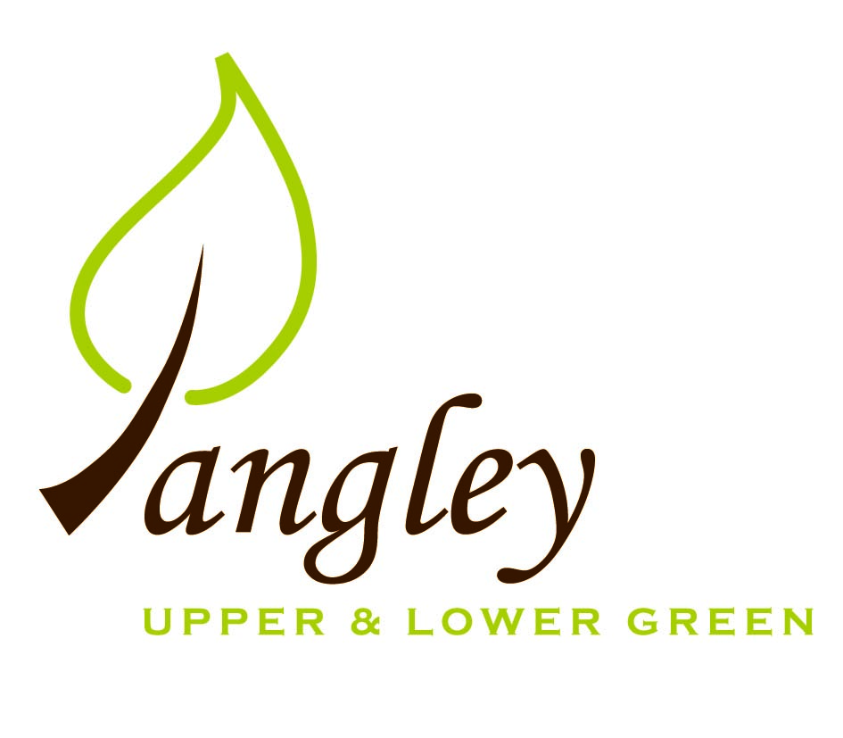

Clerk: Erica Williams
E-mail: langleyclerk@googlemail.com
13 Princes Close, Balsham, Cambridgeshire CB21 4EE

A MEETING OF LANGLEY PARISH COUNCIL
HELD AT LANGLEY COMMUNITY CENTRE ON
MONDAY 10th July 2023 at 8.00pm

MINUTES
Attended: Cllr Elkington (Chair), Cllr North (Vice-Chair), Cllr Smith, Cllr Barnes, Cllr Clark. Cllr Oliver (UDC) arrived at 8.35pm
Minutes: Erica Williams (Clerk)

1. APOLOGIES FOR ABSENCE

2. DECLARATION OF INTERESTS
It was proposed and agreed by all that Langley Parish Council is the registered owner of the village green and Councillors declare general
interests in all agenda items relating to the village green. Any other interests would be declared in the usual way.
- Cllr Elkington: 8.1, non-pecuniary, member of the Parish Council that owns the land on which the community centre is built.
- Cllr Barnes: 8.1, non-pecuniary, member of the Parish Council that owns the land on which the community centre is built.
- Cllr North: 8.1, non-pecuniary, member of the Parish Council that owns the land on which the community centre is built.
- Cllr Smith: 8.1, non-pecuniary, member of the Parish Council that owns the land on which the community centre is built.
- Cllr Clark: 8.1, non-pecuniary, member of the Parish Council that owns the land on which the community centre is built. 10.5, personal, potential new Councillor is an employee.

3. PUBLIC PARTICIPATION SESSION WITH RESPECT TO ITEMS ON THE AGENDA AND OTHER MATTERS THAT ARE OF MUTUAL INTEREST
3.1 Two members of the public attended.

4. MINUTES OF THE LAST MEETING
4.1 Councillors were asked to review the Minutes of the Parish Council meeting held on Monday 12th June. All agreed and Chair signed them off.

6. FINANCIAL CLARIFICATION
6.1 Financial Report – Bank reconciliation as at 30th June, the current account balance was £25,128.22. PC unpresented payments, £5,201.15 resulting in a current account balance of £19,927.07. Broken down as follows: Playground H&S funds £1,317.37, Ditches funds £2,000.00, Playground funds £3,214.14; PC funds £11,712.93. PC deposit account £10,166.08 (interest received of £56.93).
6.2 All Cllrs reviewed and agreed BACS run.

7. PLANNING APPLICATIONS/PROPERTY
7.1 Applications:
UTT/23/1508/HHF 1 The Kangels, Langley Upper Green – NO OBJECTIONS

8. LANGLEY VILLAGE PROJECT
8.1 Plans continuing with work at The Church and decorating work is taking place at the Community Centre. 100 Club has raised over £2000 for the Village Project. Next fundraiser is Ladies Day lunch on 19th July.

10. LOCAL ENVIRONMENT
10.1 Trees / Verges / Grass cutting – GWB provided an amended schedule for grass cutting. All Councillors voted to accept this schedule. Clerk to confirm. Clerk to chase outstanding tree works and check availability for ditch work scheduled for later in the year.
10.2 Clerk confirmed that our current insurance covers the Village Green and no signage is needed.
10.3 Clerk to book RCCE to provide presentation on Rural Affordable housing at PC meeting in October.
10.4 Community projects ongoing and locations being investigated.
10.5 Cllr Elkington proposed to co-opt Claire Anderson on to the Parish Councillor. All agreed and the PC welcomes Claire as a new Councillor.
10.6 Clerk obtaining quotes for storage of Parish Council documents.

11. PLAYGROUND
11.1 No updates.
11.2 Most playground maintenance now complete. The PC are very happy with the standard of work. Cllr North confirmed that the new dog waste bin has been installed at the top of the footpath near The Want.

12. DISTRICT COUNCIL
Cllr Oliver’s provided an update and answered questions on this from Cllrs.

13. CHEQUES FOR SIGNING
13.1 Council agreed the following BACS payments to be made:

Langley Parish Council – BACS payments for July 2023
RAS Handyman Services | Fencing and playground repairs |  | £1,323.77
RAS Handyman Services | Various playground maintenance |  | £358.85
GWB Horticulture | Grass cutting |  | £1,785.00
LCC & ST | Community Centre hire for PC meetings |  | £138.00
LCC & ST | Community Centre hire for Coronation events (to be reclaimed from grant) |  | £148.00
RCCE | Membership renewal |  | £52.80
Cllr Mike North | Reimbursement for dog waste bin |  | £153.82
Print Juice | Village Voice flyers |  | £60.00
UK Power Networks | Disconnection of electricity supply |  | £784.80
UDC | Recharge of Parish Elections cost |  | £52.47
Erica Williams | Clerks salary |  | £343.64
 |  | Total | £5,201.15
14. MATTERS TO BE RAISED BY MEMBERS FOR THE NEXT AGENDA
14.1 Please note that no decisions can lawfully be made under this item. LGA 1972, Section 12 10(2)(b) states that business must be specified; therefore, the Council cannot lawfully raise matters for decision.

15. DATE OF NEXT MEETING:
15.1 The next meeting will be on Monday 11th September at Langley Community Centre.

