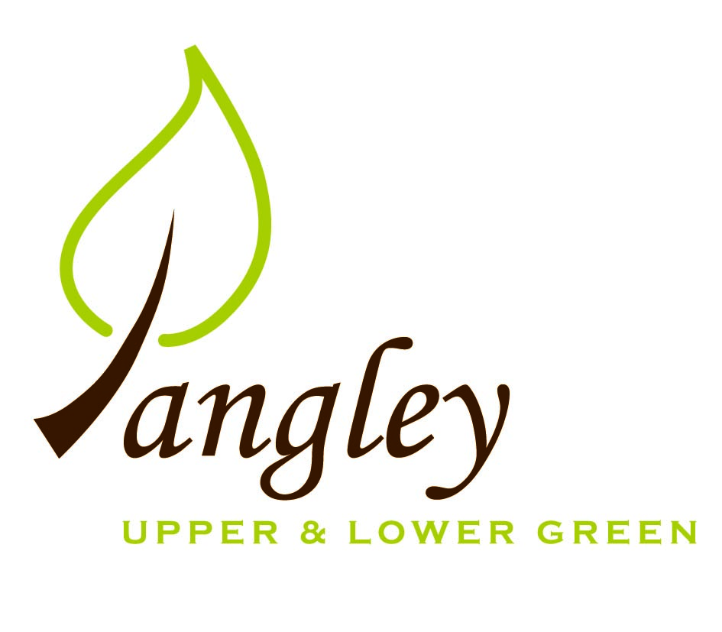

Clerk: Erica Williams
E-mail: langleyclerk@googlemail.com
13 Princes Close, Balsham, Cambridgeshire CB21 4EE

A MEETING OF LANGLEY PARISH COUNCIL
HELD AT LANGLEY COMMUNITY CENTRE ON
MONDAY 8th September 2025 at 8.00pm

MINUTES
Attended: Cllr Elkington (Chair), Cllr North (Vice-Chair) Cllr Clark, Cllr Barnes, Cllr George,
Minutes: Erica Williams (Clerk)

1. APOLOGIES FOR ABSENCE
Cllr Smith and Cllr Anderson

2. DECLARATION OF INTERESTS
It was proposed and agreed by all that Langley Parish Council is the registered owner of the village green and Councillors declare general
interests in all agenda items relating to the village green. Any other interests would be declared in the usual way.
- Cllr Elkington: 7.1 non-pecuniary, member of the Parish Council that owns the land on which the community centre is built.
- Cllr Clark: 7.1 non-pecuniary, member of the Parish Council that owns the land on which the community centre is built.
- Cllr Barnes: 7.1 non-pecuniary, member of the Parish Council that owns the land on which the community centre is built.
- Cllr North: 7.1 non-pecuniary, member of the Parish Council that owns the land on which the community centre is built.
- Cllr George: 7.1 non-pecuniary, member of the Parish Council that owns the land on which the community centre is built.

3. PUBLIC PARTICIPATION SESSION WITH RESPECT TO ITEMS ON THE AGENDA AND OTHER MATTERS THAT ARE OF MUTUAL INTEREST
3.1 Two members of the public attended. A parishioner spoke to the PC about an upcoming planning application. No comments were made.

4. MINUTES OF THE LAST MEETING
4.1 Councillors were asked to review the Minutes of the Parish Council meeting held on Monday 14th July. All agreed and Chair signed them off.

5. FINANCIAL CLARIFICATION
5.1 Financial Report – Bank reconciliation as at 31st August, the current account balance was £16,870.60. PC unpresented payments, £1,002.16 resulting in a current account balance of £15,868.44. Broken down as follows: Playground H&S funds £239.37, Ditches funds £1,670.00, Speed sign funds £4,014.14; PC funds £9,944.93. PC deposit account £10,719.77.
5.2 All Cllrs reviewed and agreed BACS run.
5.3 Risk Assessment form to be completed at next PC meeting, with all Councillors present.
5.4 Clerk confirmed that paperwork confirming disconnection of electricity supply to former phone box has been completed and account with SSE closed. Small refund to be expected. Clerk to lodge complaint with UK Power Networks.
5.5 Following the presentation of quotes from the Clerk for a new PC website and email addresses, Cllr Elkington proposed that the PC proceed with the supplier Aubergine to provide a new website and email addresses to ensure compliance and accessibility requirements are met. Cllr Clark seconded. All agreed. Clerk to action.
5.6 Following a discussion, Cllr North proposed that the PC subscribe to an accounting package offered by Scribe in order to better manage and report finances, along with Year End. Cllr Barnes seconded. All agreed. Clerk to action.
5.7 Cllr Elkington suggested that the PC make a donation to Scotty’s Little Soldiers. Cllrs agreed to make a donation of £100. Clerk to action.

6. PLANNING APPLICATIONS/PROPERTY
6.1 None received.

7. LOCAL ENVIRONMENT
7.1 Contractor suggested meeting with Cllrs North and Smith to action removal of dead grass clippings. Meeting to be booked. Potterills railings still awaiting cut. Clerk to chase.
7.2 Cage still to be removed from tree on Village Green. Clerk to contact additional contractors regarding outstanding tree works.
7.3 Work on potholes commenced today (8th September).
7.4 No further updates. Grants would need to be sought for any pond work.
7.5 Locations for VAS signs approved. Awaiting contracts from Legal Department.
7.6 Introduction meeting booked with new contact at Hastoe and RCCE regarding Low Cost Housing initiative.
7.7 Cllr George to investigate Asset of Community Value process for The Bull PH.

8. PLAYGROUND
8.1 Swing has been repaired. Cllr North repaired loose boards on the climbing wall. Cllr Clark to look at matting area around basketball net and report back.

9. DISTRICT AND COUNTY COUNCIL
9.1 Cllr Oliver provided updated to Cllrs and answered questions.

10. BACS PAYMENTS
10.1 Council agreed the following BACS payments to be made:
Langley Parish Council – BACS payments for September 2025
Erica Williams | Clerks salary (paid in August) | BACS | £430.17
Compact Contracting Services | Grass cutting (paid in August) | BACS | £552.85
Erica Williams | Clerks salary | BACS | £404.31
Compact Contracting Services | Grass cutting | BACS | £552.85
RAS Handyman Services | Playground maintenance | BACS | £45.00
 |  | Total | £1,002.16

11. MATTERS TO BE RAISED BY MEMBERS FOR THE NEXT AGENDA
11.1 Asset of Community Value
11.2 Oak Tree
11.3 Defibrillator checks
11.4 Bootcamp on the Green

12. DATE OF NEXT MEETING:
12.1 The next meeting will be on Monday 13th October 2025 at Langley Community Centre at 8.00pm.

